

*Released Aug 28th*

**Hello Team Officials,**

We are excited to announce that we have reached **116 Teams.**  Thank you for your support!

**Tournament Information**

* **Tournament Headquarters**: Clippers Arena – Main Floor
* **2025 Tournament Schedule**: Now available in the **Documents Section** of the main event page.
* **Official Website**:  <https://www2.sportacularevent.com/portal//events/event/116>
* (Please do not contact arenas or the city for scores). If you find what you believe as an incorrect score, please notify us via email @ [info@sportacularevents.com](mailto:info@sportacularevents.com) to help expedite inquiries. Please in subject line use: Game Concern - the division and GM# - then share your concern. Saturday is a very busy day for advancing teams. We have a process which identifies which divisions have to be advanced in a chronological process. Many inquiries are made and the pool or divisions has not completed their final RR games in order for us to calculate and advance teams. We appreciate everyone’s patience.
* The 2025 Schedule is now posted in the document section of the main event page
* Teams ***Do Not*** have to register at Headquarters
* Team Ramp Game Codes will be made available once everything is uploaded. The OWHA is still populating divisions in the Tournament link, so please remain patient as teams receive their Final Roster Approvals.

**Team Roster Submission**

* Official PDF Rosters MUST be uploaded to your **Sportacular Events account.**
* Mandatory request for all teams - Log in to your Sportacular Event Acct, go to **MY TEAMS**, select your registered team, and click **EDIT** to update your roster and bench staff to ensure correct contact information is correct. Players only require jersey# and name.
* *Yes, it needs to be manually typed in for the information below*
* Be sure to save your updates to ensure accuracy for game sheets
* A single-page game sheet system is used for consistency between ice-level officials and administration.
* You may now also, as shown where to Upload your teams official PDF roster.

**2025 Tournament Updates**

* **"Player of the Game" awards** will be given for every game pickup at Arena Convenor Table in lobby you will sign for the award.
* Special **Finals** Player of the Game award is a commemorate gold medal
* **Championship Finals**: Winners receive Gold Medals and an Arena Banner; finalists receive Silver Medals.
* **New Awards**: Same as Player of game awards, if a player has a Hat Trick or Shutout
  + "Wholly Moly Who's That Goalie" Shutout Awards
  + "Holy Hat Trick" Awards for players scoring a hat trick

**Important Rules & Reminders**

* **Player Eligibility**: Players can only compete with one team in one tournament during the weekend
* **Pickup Players**: Any team using an OWHA Pickup Players must follow these rules or face Forfeiture and or Suspensions and fines.
* **Any team Found to be using an illegal player or playing suspended players will be removed from the tournament and any further games will results in Game Forfeitures.** **The OWHA Will also be notified as required**
* **Rep Teams**: Allowed **max 3** replacements but cannot replace suspended players. Rep teams may only use Players from below levels of play – No Lateral Callups even if playing up in a combined division. If a team has been found to use an illegal callup or player the team will be removed from the event

**ALL** Teams cannot exceed their official roster limit at any time.

* **Equipment Rules**:
* **USA Teams**: Mandatory **mouthguards** (per USA Hockey Insurance).
* **Canadian Teams**: Mandatory **BNQ neck guards** (per Hockey Canada)
* **Suspensions**: Hockey Canada and OWHA SUSPENSION rules shall apply where required. All suspensions must be reported to **OWHA** via email and await their direction as to number of games. You must comply. Clearance must be received before returning to play. Teams from out of Province will be notified of IF a member of team is under suspension
* **Travel Permits**: All out-of-province teams must submit their travel permits and email to Sportacular Events. If Travel permit is not provided the team is not allowed to play it’s a Hockey Canada Insurance Rule
* **Rosters**: Have a copy of your roster available in the event of any discrepancy
* **Tournament Rules**: Posted live on the Sportacular site. Please also note ***we do not*** use GF/GA we instead use the Tie Breaker Calculator chart in the document sections.
* Home and Away Jersey Colors Sect 17 of OWHA Handbook
* Home Teams will wear Dark colored Jerseys and visitor teams will wear light.
* NOTE: for the 2025/26 Season Home teams have the Option to wear Light Colored Jerseys.
* If they choose to wear Light Colored as Home Team, they must notify visiting team once games are scheduled. We recommend to approach the other team when at the arena.

**Game Day Procedures**

* **Jersey Color Conflicts**: Teams should bring an extra set of jerseys or pinnies to avoid conflicts.
* **Championship Awards & Photos**: Arena banners and medals will be awarded **off the ice** due to safety and City and Town insurance regulations
* **Dressing Rooms**:
  + Bring your own lock where required.
  + Keep rooms clean before vacating.
* **Game Start Times**: Games may begin up to **20 minutes early** based on arena convenor coordination
* **Check-in Requirements**: Team managers or head coaches should check in with arena convenor in lobby before each game. You do not need to check in a headquarters.
* **Player of the Game Award**: A player of the game DOG TAG will be provided at the sign in table prior to the start of each game and awarded by the coach who will sign for the item
* **Shutout/Hatrick Awards:** Available at the convenor table at the end of your game
* **Identifying Event Staff**: Sportacular Event Staff will wear red jackets with “Event Staff on the bank. Ask for help at any game sheet sign-in area
* **RAMP Game Codes**: Will be emailed and also available at game sheet convenor tables.

**Final Notes**

* **2025 Tournament Rules** go live 7 days before.
* If we promised thank-you or incentives items, please remind us before the first game so we have them ready for you.
* Stouffville arena has additional parking behind the rinks

We look forward to seeing you all in **soon to officially Kickoff the new season!**

Check the **event main page** for ongoing updates. <https://www2.sportacularevent.com/portal//events/event/116>

Thank you, and best of luck to all teams!

**Tournament Vendors**

**Stouffville Arena**

* Authentic Memories Team and Action Photos
* Busy Beads Croc Charms
* Saturday & Sunday only The Very Exciting New Product launch LCD Team Dressing Room Door Light <https://www.henderworks.ca/clutchlit>
* Friday & Saturday only The PWHL Pop Up Merch Sale
* Glow Town indoor Golf Fun, Fun -Fun

**Clippers Arena**

* Br2 they have amazing new clothing designs and special offerings as the Event Clothing Provider
* Lily from Harly Imports & Toys
* Skate Swipe New Hockey Product

**Canlan Scarborough**

**Designated Warm up Areas:**

Please note that loud music is not permitted in any of the Lobbies in Markham, Stouffville and Richmond Hill Rinks. In addition, that the playing of Loud Music is Prohibited behind the townhouses to the West of the Stouffville Arena.

Designated Warm up Areas:

Stouffville Arena --

Indoors at the back of the rinks on Pad A & B or on Outdoors on the soccer Fields or Track.

Stouffville Clippers Complex:

In the upper Area of the rinks or inside the Rinks or outdoors on Grassy Areas.

Angus Glen CC

Designated indoor warm up areas are inside the rinks. Warms ups and loud music are not permitted anywhere else inside the complex. There are soccer fields in the back of the complex or out front on grassy areas.

Markham Centennial CC -

Warm up Areas are inside the upper bowl of the rinks or the park to the West of the Complex.

Mt Joy CC:

Warm ups are to take place Inside the rink or outdoors.

Tom Graham

Warm up Areas are inside the rinks or outdoors on grassy areas.

Ed Sackfield:

Warm ups are to take place Inside the rink or outdoors.

***********************

**WELCOME TO "THE 2025 STARSFEST" PHOTO PACKAGE!**

WE DO **NOT** TAKE**RANDOM** PHOTOS- ACTION PHOTOS BY REQUEST ONLY

**1) TEAM LOCKER PHOTO**: PLEASE BOOK APPT- NO OBLIGATION TO PURCHASE  
13 x 19 photo - **$45** ea. - or 7 or more - **$35 ea.**  
limited number of frames available for **ADDITIONAL**-$40

**SEASON OPENER SPECIAL- BUY 10 - PRICE IS $25 ea**

Please contact me to reserve a time-  
**2) TEAM ACTION PHOTOS: DIGITAL IMAGES ARE EMAILED TO MANAGER**

**OPTION A: $250**per game approx.. 150 - 200 images

**OPTION B:-$350**-FOR TWO GAMES approx.. 400-500 images

**WELCOME SPECIAL**: FOR THE FIRST**SIX** TEAMS TO BOOK EITHER PACKAGE A OR B- **DEDUCT $25 FROM TOTAL**

(PLEASE BOOK (and pay) PRIOR THE EVENT)- So I can schedule the proper number of PROFESSIONAL photographers

Please note- Team photo image is **NOT**included in Action Photo Package

NOTE: IF YOUR TEAM DOES NOT BOOK AN ACTION PHOTO PACKAGE- PLEASE LET YOUR PARENTS KNOW THEY NEED TO REQUESTS PHOTOS- NO RANDOM SHOTS!

Thank you and if you have any questions or special requests- please let me know

Good Luck

Eric Niskanen-416-579-1845

[eric.niskanen@sympatico.ca](mailto:eric.niskanen@sympatico.ca)

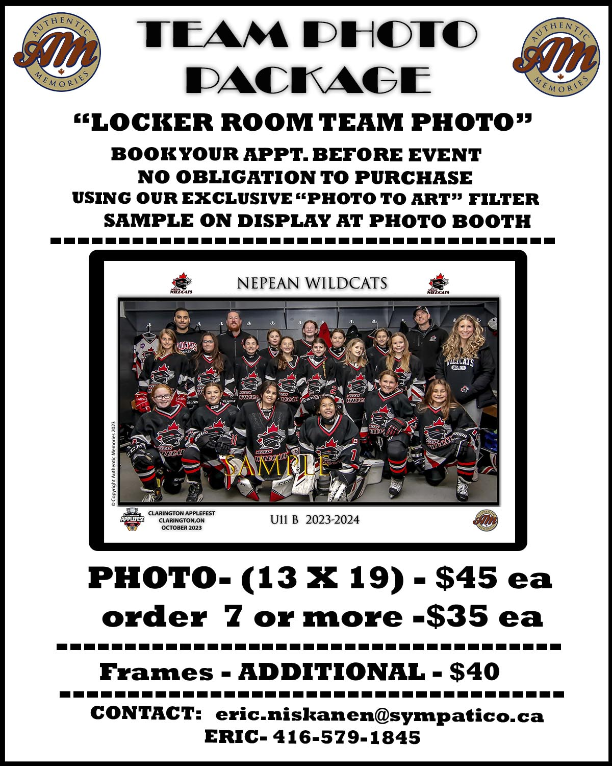

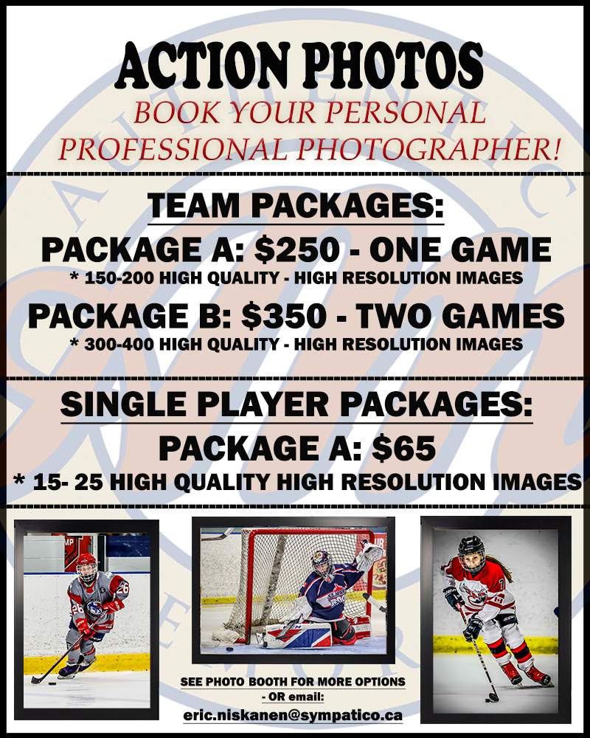

Live Barn Markham contact that Angus, Mt Joy & Centennial all should be live.

Town of Stouffville has confirmed all rinks at Clippers & Stouffville Arena will be available on Live Barn as well.

**Skate Sharpening Info:**

Stouffville:

There is skate sharpening available at Stouffville Arena and Clippers Complex by Cutting Edge Pro Shops <https://cuttingedgeproshops.com/locations/stouffville/skate-sharpening-stouffville/>. He will have guys at both rinks all weekend if anyone asks. I spoke to him on Tuesday evening and told him how late the games go each day an that they start at 8AM and onward.  Pro Wear Sports <https://prowearsports.com/> in plaza with the Esso also has skate sharpening

In Markham (sometimes at Angus there is a guy however not sure if he will be there for public skate none at Mt Joy or Centennial) and in Richmond Hill not sure if they do. However, the Hockey Lion is close by in Markham and there is also one in Richmond Hill if anyone is looking for a place that does great work

<https://www.hockeylion.ca>

HOCKEY LION RICHMOND HILL  
  
9821 Leslie Street, Unit 106  
Richmond Hill, L4B 3Y4  
Ontario, Canada  
  
Opens 10 AM on Fri/Sat/Sun  
  
HOCKEY LION MARKHAM  
  
6050 Highway 7 East, Unit 4  
Markham, L3P 3A9  
Ontario, Canada  
  
Opens 10 AM on Fri/Sat closed Sunday